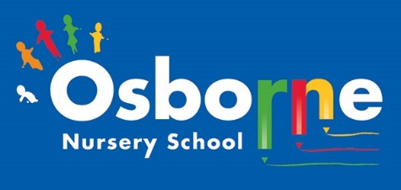
Osborne News
www. osbornenurseryschool.co.uk

July 2026 
Dates for your diary:
Thursdays: Stay and Play (under 2s) every Thursday morning – 9:45 – 11:15am at OSBORNE NURSERY SCHOOL.
Transition events through July – Please ensure you check emails and letters for visits to your child’s new school.
July 2026 – Visits for new families at Nursery
Wednesday 8th July – Osborne Nursery School 50 years celebration!
– Transition Celebrations!
Friday 17th July – last day of term
Monday 31st August – BANK HOLIDAY
Tuesday 1st September – NURSERY CLOSED FOR STAFF TRAINING
Wednesday 2nd September – Welcoming new children and home visits for our new Little Learners.
Please remember to telephone us on 0121 675 1123 if your child is too ill or has an appointment and won’t be coming to nursery.

Nursery News:
What a wonderful year we have had! We would like to thank all parents and carers for their support over the year.
Some of our children are starting their new journey in primary school – we will miss you all and we know you will continue to shine! We are all very proud of your achievements.

Children returning to Nursery School in September 2026
Children returning to Nursery School will come back into school from Wednesday 2nd
September. You will have a letter confirming your child’s pattern of attendance. We look forward to seeing you in September. Please remember to supply nappies and changes of clothes in a named bag.
Thank you.
Sun Safety:
1.Wear sun cream and keep applying
2.Drink lots of water
3.Spend time out of the sunshine, especially between 11am and 3pm
4.Wear a hat
https://www.bbc.co.uk/cbeebies/watch/sun-safety-for-kids
We would like to wish you a very safe and happy summer break. Good luck to all of the children starting school and we look forward to children returning to nursery and new families too.

Attendance is very important at Nursery. We like to see you for all your sessions each week. Families should aim for attendance to be between 95 and 100%. Look out for the Cool Kittens stickers! Congratulations to TRIANGLES PM and for the best attendance in Nursery in May 2026. FANTASTIC!! Well done to the parents and carers too.


July 7th, 2026, is National Thank You Day!
A day to celebrate all the things that keep us connected in our communities, saying ‘thank you’ to each other – We would like to say a big thank you all our children, parents, carers and staff for everyone’s hard work this academic year!

It has been confirmed that we are now a SILVER Rights Respecting School!
GOLD is the next challenge!
Children have a right to a voice - Children have a right to a voice because their views, feelings, and experiences matter. Allowing children to express their opinions helps them feel valued, respected, and included in decisions that affect their lives.

Ronnie Rabbit is helping the children understand their rights.

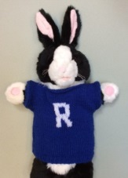

Rights Respecting Schools Award (RRSA)

Internet Safety: Please have a read of the Under 5s On Line Safety Checklist from internetmatters.org . At our setting, we help children begin to understand how to use technology safely and responsibly. Through age-appropriate discussions and activities, children learn that they should always tell a trusted adult if they see something online that worries or upsets them. We encourage all of you at home to promote the safe use of devices and promote the importance of kindness, privacy and asking for help when needed.

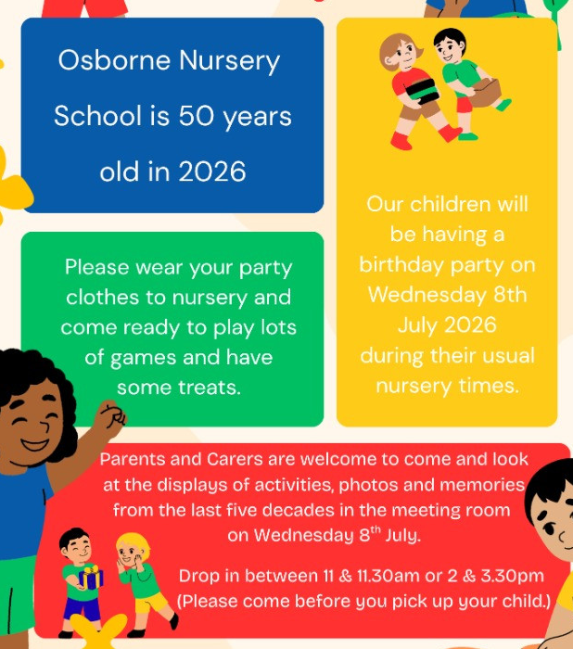
Remember that Wednesday 8th July is a special day for Osborne Nursery School. You can call into nursery to see the displays and learn about the history of the nursery.
The children will be having a party to celebrate so wear your party clothes!
Little Learners went to Sutton Park – we experienced sunshine, rain, hail and sunshine again! We had such a lovely time feeding the ducks and playing in the park together!
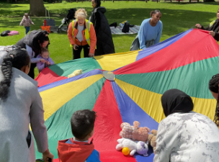
When is was Explorers turn for their trip , it was very unfortunate that the trains were cancelled due to the very hot weather so we could not go.
We had fun at nursery instead with water and lots of activities to help keep us cool !!
